**Project Design Phase-II**

**Data Flow Diagram & User Stories**

|  |  |
| --- | --- |
| Date | 25 June 2025 |
| Team ID | LTVIP2025TMID59497 |
| Project Name | Freelance Finder |
| Maximum Marks | 4 Marks |

**Data Flow Diagrams:**

A Data Flow Diagram (DFD) is a traditional visual representation of the information flows within a system. A neat and clear DFD can depict the right amount of the system requirement graphically. It shows how data enters and leaves the system, what changes the information, and where data is stored.

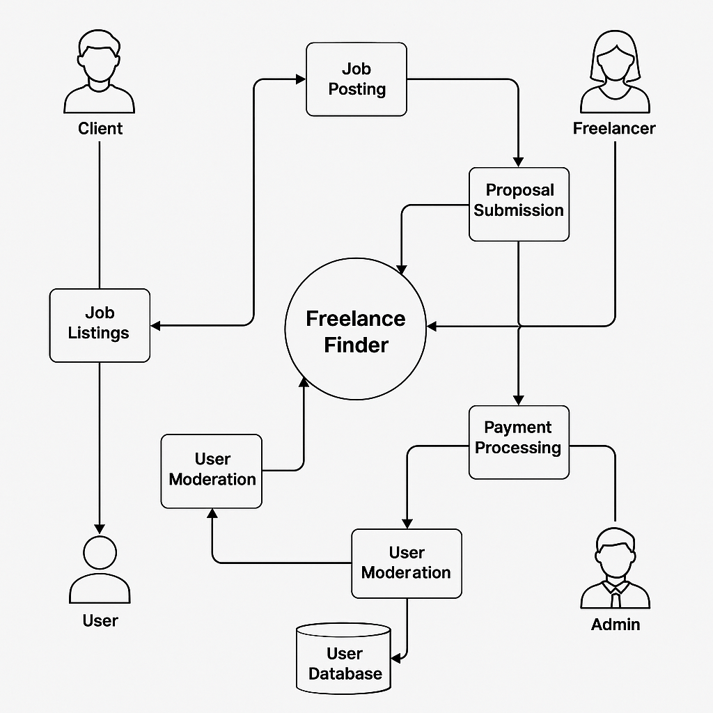

**User Stories**

Use the below template to list all the user stories for the product.

| **User Type** | **Functional Requirement (Epic)** | **User Story Number** | **User Story / Task** | **Acceptance criteria** | **Priority** | **Release** |
| --- | --- | --- | --- | --- | --- | --- |
| Client | Job posting | USN-1 | As a client, I can post a job with title, description, skills, and budget. | Job appears on freelancer's dashboard. | High | Sprint-1 |
| Freelancer | Proposal Submission | USN-2 | As a freelancer, I can submit proposals for jobs. | Client receives proposals with details. | High | Sprint-1 |
| User | |  | | --- | |  |  |  | | --- | | Messaging | | USN-3 | As a user, I can chat with the other party in real-time. | Messages appear instantly in chat window | Medium | Sprint-2 |
| Client | |  | | --- | |  |  |  | | --- | | Payment  Processing | | USN-4 | As a client, I can release milestone payments after work is delivered. | Freelancer receives payment and notification. | high | Sprint-2 |
| admin | |  | | --- | |  |  |  | | --- | | User Moderation | | USN-5 | As an admin, I can review and act on reported users or flagged content. | All actions are logged and reflected in user status. | High | Sprint-1 |